Endovascular therapy for acute ischaemic stroke: the Pragmatic Ischaemic Stroke Thrombectomy Evaluation (PISTE) randomised, controlled trial

Keith W Muir,1 Gary A Ford,2 Claudia-Martina Messow,3 Ian Ford,3 Alicia Murray,1 Andrew Clifton,4 Martin M Brown,5 Jeremy Madigan,4 Rob Lenthall,6
Fergus Robertson,5 Anand Dixit,7 Geoffrey C Cloud,4 Joanna Wardlaw,8 Janet Freeman,9 Philip White,7 on behalf of the PISTE Investigators

For numbered afﬁliations see end of article.

Correspondence to Professor Keith W Muir, Institute of Neuroscience & Psychology, University of Glasgow, Queen Elizabeth University Hospital, Glasgow G51 4TF, UK; keith.muir@glasgow.ac.uk

ABSTRACT
Objective The Pragmatic Ischaemic Thrombectomy Evaluation (PISTE) trial was a multicentre, randomised, controlled clinical trial comparing intravenous thrombolysis (IVT) alone with IVT and adjunctive intra- arterial mechanical thrombectomy (MT) in patients who had acute ischaemic stroke with large artery occlusive anterior circulation stroke conﬁrmed on CT angiography (CTA).
Design Eligible patients had IVT started within
4.5 hours of stroke symptom onset. Those randomised to additional MT underwent thrombectomy using any Conformité Européene (CE)-marked device, with target interval times for IVT start to arterial puncture of
<90 min. The primary outcome was the proportion of patients achieving independence deﬁned by a modiﬁed Rankin Scale (mRS) score of 0–2 at day 90.
Results Ten UK centres enrolled 65 patients between April 2013 and April 2015. Median National Institutes of Health Stroke Scale score was 16 (IQR 13–21).
Median stroke onset to IVT start was 120 min. In the intention-to-treat analysis, there was no signiﬁcant difference in disability-free survival at day 90 with MT (absolute difference 11%, adjusted OR 2.12, 95% CI
0.65 to 6.94, p=0.20). Secondary analyses showed signiﬁcantly greater likelihood of full neurological recovery (mRS 0–1) at day 90 (OR 7.6, 95% CI 1.6 to 37.2, p=0.010). In the per-protocol population (n=58), the primary and most secondary clinical outcomes signiﬁcantly favoured MT (absolute difference in mRS 0–2 of 22% and adjusted OR 4.9, 95% CI 1.2 to 19.7, p=0.021).
Conclusions The trial did not ﬁnd a signiﬁcant difference between treatment groups for the primary end point. However, the effect size was consistent with published data and across primary and secondary end points. Proceeding as fast as possible to MT after CTA conﬁrmation of large artery occlusion on a background of intravenous alteplase is safe, improves excellent clinical outcomes and, in the per-protocol population, improves disability-free survival.
Trial registration number NCT01745692; Results.

BACKGROUND
To cite: Muir KW, Ford GA, Messow C-M, et al. J Neurol Neurosurg Psychiatry 2017;88:38–44.
Recanalisation and reperfusion of the brain are associated with greater chance of favourable outcome after acute ischaemic stroke.1 Intravenous
thrombolysis with recombinant tissue plasminogen activator (rtPA) improves the likelihood of recanali- sation, and treatment within 4.5 hours of stroke onset is associated with signiﬁcantly increased like- lihood of recovery without disability by 90 days after stroke.2 However, among those patients with large artery occlusion (LAO) in the carotid circula- tion (occlusion of the intracranial internal carotid artery (ICA), or proximal middle cerebral artery (MCA)), intravenous rtPA is able to effect recanali- sation in only a small proportion of patients,3 and despite intravenous thrombolytic therapy, a high proportion of patients with LAO stroke die or remain disabled.
Intra-arterial treatment of stroke, initially with thrombolytic drugs and then with endovascular devices designed to fragment or extract the causa- tive thrombus, has been investigated over many years. Devices developed in the early 2000s achieved higher rates of recanalisation, but clinical outcomes were not clearly superior to those achieved by intravenous thrombolysis (IVT) alone.4 5 The third Interventional Management of Stroke trial (IMS-3)6 found no difference in outcome between patients treated with IVT alone compared to IVT with additional intra-arterial treatment. The IMS-3 trial used predominantly older devices that were found subsequently to be less effective than the later stent-retriever devices7 8 and did not have non-invasive vascular imaging to establish the presence of treatable LAO in the majority of its patients. The trial also identiﬁed a strongly time-dependent likelihood of recovery to independence, emphasising the importance of fast intervention times.9
A series of ﬁve trials using angiographic imaging and mechanical thrombectomy (MT) predomin- antly using stent-retrievers reported positive results in 2015 in favour of MT,10–14 with results from two further trials presented. All trials were con- ducted at expert stroke centres with highly efﬁcient systems for delivery of MT and experience in this modality of treatment. Whether these ﬁndings are generalisable to countries with different healthcare systems, such as the UK, was unclear.
We undertook the PISTE trial to evaluate the efﬁcacy of MT in addition to best medical therapy, including IVT, compared to best medical therapy

alone. Recruitment to the trial was halted after review of other trial data.

METHODS
PISTE was a multicentre, randomised, controlled, parallel group trial of prospective, randomised, open, blinded end point evalu- ation (PROBE) design (clinicaltrials.gov NCT01745692). Ethical approvals were given by the Scotland A Research Ethics Committee (12/SS/0059) and the National Research Ethics Service Committee North East-Newcastle & North Tyneside 2
(12-NE-0315). Adult patients ≥18 years were eligible if present- ing with acute supratentorial ischaemic stroke and eligible for
IVT started within 4.5 hours of symptom onset. If non-invasive angiographic imaging with CT angiography (CTA) or magnetic resonance angiography showed occlusion of the intracranial ICA, M1 segment of the MCA or a single M2 MCA branch, patients were eligible for randomisation. We excluded patients with contraindications to IVT, life expectancy limited to
<90 days, with chronic extracranial ICA occlusion or with extensive early hypodensity on non-contrast CT brain involving more than one-third of the MCA territory. All patients had IVT initiated at the neurovascular centre.
Neurointerventional centres were required to have a minimum of two experienced operators—with ≥10 thrombec- tomy procedures per centre for acute stroke treatment in the preceding 18 months, and to have extensive experience of other intracranial endovascular procedures—with centre volumes
exceeding 120 per annum for the past 3 years and individual operators exceeding 120 in total; of which, at least 60 were in the preceding 18 months. Intervention was to be initiated as fast as possible after conﬁrming eligibility, and a maximum of 90 min from start of IVT to start of the MT procedure (groin puncture) was permitted. The target vessel should have been cannulated within a maximum of 6 hours of symptom onset.
Patients were randomised 1:1 to receive best medical therapy with IVT alone, or undergo additional (adjunctive) MTwith any operator-selected CE-marked device approved for intracranial clot removal. Allocation used a minimisation algorithm, includ- ing age group, stroke severity on the National Institutes of Health Stroke Scale (NIHSS) and symptom onset-to-treatment time. Randomisation was conducted using an interactive voice-response system managed by the Robertson Centre for Biostatistics, University of Glasgow.
The primary outcome was deﬁned as the proportion of patients achieving independence at day 90 after stroke onset, based on a score of 0, 1 or 2 on the modiﬁed Rankin Scale (mRS).15 16 Day 90 outcomes were assessed by site staff blind to
treatment allocation. We deﬁned secondary outcome measures as excellent recovery (mRS score 0–1); change in the distribu- tion of scores on the mRS; early major neurological improve- ment (improvement by ≥8 points on the NIHSS or NIHSS of 0 or 1 at 24 hours after stroke); ‘home time’ (time spent in usual residence between stroke onset and day 90);17 the proportion of patients with recanalisation on the IST-3 CTA scale18 at
24 hours; mortality; and the incidence of symptomatic intracer- ebral haemorrhage (SICH) deﬁned using SITS-MOST criteria19 as a parenchymal haematoma type 220 on CT or MRI brain at 24–36 hours and a clinical worsening of ≥4 points on the NIHSS.
All imaging studies were uploaded to a central imaging reposi- tory, anonymised, validated and loaded into a web-based viewing system (Systematic Image Review System-2, SIRS-221) for reading by three neuroradiologists blind to treatment alloca- tion as well as all clinical data as a ‘core lab’ interpretation. Extent of early ischaemic change on brain imaging was deﬁned by the Alberta Stroke Programme Early CT score (ASPECTS).22 The site of vessel occlusion at baseline was deﬁned on CT angiography (CTA). Collateral circulation was graded as poor, moderate or good.11 The extent of thrombus was graded using the clot burden scale.23 Recanalisation at the end of the proced- ure among those allocated additional MT was graded by the modiﬁed Thrombolysis in Cerebral Infarction (mTICI) scale with reperfusion success deﬁned as mTICI score 2b or
3. Recanalisation at 24 hours was assessed on repeat CTA using the third International Stroke Trial (IST-3) CTA score.18
The intention-to-treat (ITT) population consists of all patients randomised in the trial, and the per-protocol population consists of all patients in the ITT population who did not have any major protocol violation identiﬁed prior to database lock.
The primary efﬁcacy analysis is the comparison of the primary outcome mRS ≤2 at day 90 between treatment groups using logistic regression adjusting for the minimisation factors used in the randomisation. These were age group (≤80 or >80), NIHSS score (6–12, 13–19, 20–42), time to rtPA (<3 hours,
≥3 hours) and study site. Analyses were performed identically for ITT and per-protocol populations. For the analysis, sites
recruiting fewer than 10 patients were grouped together. Binary secondary outcomes were analysed analogously. mRS distribu- tion was analysed using proportional odds logistic regression instead of logistic regression, additionally adjusting for prestroke (baseline) mRS. The number of days in usual residence between day 0 and day 90 was analysed using exact permutation tests.
The statistical analysis plan was agreed prior to database lock and unblinding. Statistical analyses have been carried out using

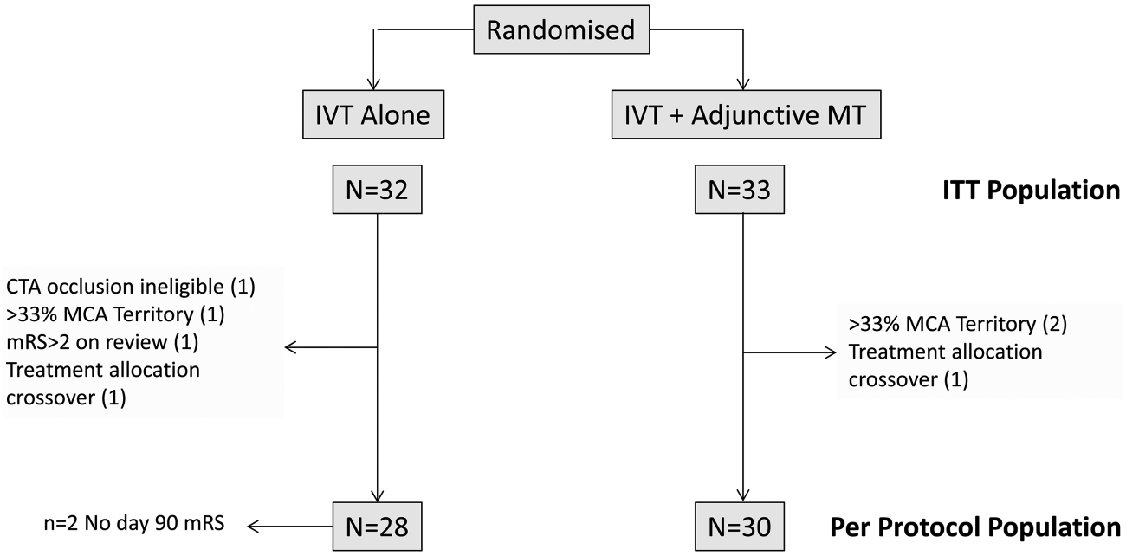
Figure 1 CONSORT ﬂow chart showing disposition of trial participants. CTA, CT angiography; ITT, intention to treat; IVT, intravenous thrombolysis; MCA, middle cerebral artery; mRS, modiﬁed Rankin Scale; MT, mechanical thrombectomy.

R V.3.0.1 (R Foundation for Statistical Computing, Vienna, Austria). The signiﬁcance level for the primary analysis is 0.05.
Table 1 Demographics, medical history, stroke characteristics and
treatment process times
Intravenous rtPA
Smoker (current), n (%) MI or IHD, n (%)
Previous stroke, n (%) Diabetes, n (%) Hypertension, n (%) Atrial fibrillation, n (%)
Prestroke antithrombotic therapy, n Aspirin
Clopidogrel Warfarin
Direct oral anticoagulant Glucose, mmol/L (mean±SD)
Pretreatment systolic/diastolic BP mm Hg (mean±SD)
NIHSS median, range ASPECTS median, range
3 (9%)
6 (19%)
2 (6%)
6 (19%)
17 (53%)
8 (25%)
4 (12%)
4 (12%)
3 (9%)
11 (33%)
17 (52%)
15 (46%)
3 (9%)
0
2 (6%)
0
7.3 (3.4)
144/83 (25/18)
2 (6%)
1 (3%)
1 (3%)
3 (9%)
8.0 (3.2)
147/77 (23/15)
14 (6–29)
9 (2–10)
18 (6–24)
9 (4–10)
CTA occlusion site, n (%)
ASPECTS, Alberta Stroke Programme Early CT Score; BP, blood pressure; CTA, CT angiography; ICA, internal carotid artery; IHD, ischaemic heart disease; IVT, intravenous thrombolysis; MCA, middle cerebral artery; MI, myocardial infarction; mRS, modified Rankin Scale; MT, mechanical thrombectomy; NIHSS, National Institutes of Health Stroke Scale; rtPA, recombinant tissue plasminogen activator.
The original sample size calculation assumed that 44% of intravenous-treated and 57% of MT-treated patients would achieve mRS 0–2, based on the CTA subgroup of IMS-3.24 This yielded a sample size of ∼200 participants per group for 80% power, p=0.05. Since a more conservative 10% absolute increase in independent recovery would have been clinically
 | (IVT) | IVT+MT
n | 32 | 33
Age, years, mean±SD | 64±16 | 67±17
>80 years, n (%) | 3 (9%) | 6 (18%)
Male, n (%) | 16 (50%) | 13 (39%)
Estimated prestroke mRS
0 | 28 (88%) | 27 (82%)
1 | 1 (3%) | 5 (15%)
≥2 | 3 (9%) | 1 (3%)

worthwhile, a sample size of 400 participants per group was ori- ginally planned (assuming 45% and 55% mRS 0–2 in the two groups).

RESULTS
Between April 2013 and April 2015, 65 patients were recruited at 10 centres in the UK. Trial recruitment was suspended in April 2015 following presentation of other relevant thrombec- tomy trial results and ended in June 2015. Seven patients were excluded from a per-protocol analysis based on major protocol deviations (ﬁgure 1). IVT alone was allocated to 32 patients and IVT with additional MT in 33. Two patients were lost to follow-up at day 90, with no mRS data available, both in the IVT-only group. Major demographic and medical history factors are detailed in table 1.
Those randomised to receive MT were older, more often female, had more severe strokes, higher prevalence of some vas- cular risk factors (diabetes, atrial ﬁbrillation) and a higher pro- portion had prestroke impairment on estimated mRS; a higher proportion had good collateral score and favourable ASPECT score (table 1).
0–4, n (%) | 1 (3%) | 1 (3%)
5–7, n (%) | 9 (28%) | 6 (18%)
8–10, n (%) | 22 (69%) | 26 (79%)
ICA T/L±M1±M2 | 6 (19%) | 4 (14%)
MCA M1±M2 | 21 (65%) | 22 (76%)
MCA M2 | 5 (16%) | 3 (10%)
Collateral score, n (%)
Good | 12 (40%) | 18 (55%)
Moderate | 12 (40%) | 10 (30%)
Poor | 6 (20%) | 5 (15%)
Extracranial ICA occlusion present, n | 1 (3%) | 1 (3%)
(%)
Clot burden score, median (IQR) | 6 (4, 7) | 7 (4, 8)
Process times, min, median (IQR)
Symptom onset to IVT start | 120 (62, 238) | 120 (61, 242)
Symptom onset to randomisation | 150 (88, 268) | 150 (78, 271)
IVT start to groin puncture |  | 82 (28, 140)
Randomisation to groin puncture |  | 58 (12, 87)
Groin puncture to device removal Total time, onset to procedure end Poststroke antithrombotic therapy, n |  | 49 (15, 137)  251 (181, 390)
Aspirin | 17 (53%) | 20 (61%)
Clopidogrel | 10 (31%) | 11 (33%)
Warfarin | 1 (3%) | 2 (6%)
Direct oral anticoagulant | 2 (6%) | 3 (9%)

Procedural outcomes
Procedural timelines (table 1) were within protocol- recommended parameters. IVTwas started a median of 120 min (IQR 93–150 min) after onset of symptoms. Among those allo- cated MT, interventional times were short and consistent with protocol recommendations. Total time from symptom onset to end of MT procedure was median 251 min.
Stent-retriever devices were used ﬁrst in 68% of procedures and aspiration devices in 32%. General anaesthesia was used in 10/32 (31%) of patients and sedation in 22/32 (69%). In 25/32 (81%) patients (one patient did not undergo MT as rando- mised), a single device was used. TICI 2b-3 reperfusion at the end of MT procedure was achieved in 26/30 assessable immedi- ate postprocedure angiograms (87%).
CTA at ∼24 hours was completed in 51/65 (78%) of patients and showed reduced likelihood of vessel occlusion among those
randomised to additional MT compared to those treated with IVT alone. The proportion with an IST-3 score >1 (at least partial ﬁlling of major branches of the target vessel) was 77% vs 38%, and the proportion with IST3 score of 4 (complete patency, normal appearance) was 69% vs 33% (OR 0.18, 95% CI 0.05 to 0.64, p=0.008 in proportional odds regression of IST3 scores).

Primary outcome
In the ITT population, the difference in the proportion achiev- ing mRS 0–2 at day 90 (51% vs 40%, adjusted OR 2.12, 95% CI 0.65 to 6.94, p=0.204) was not signiﬁcant. In the per- protocol population, however, there was a signiﬁcant effect in

favour of adjunctive MT after adjustment for minimisation vari- ables, with an absolute difference in the proportion achieving mRS 0–2 at day 90 of 22% (57% vs 35%, OR 4.92, 95% CI
1.23 to 19.69, p=0.021) (table 2 and ﬁgure 2).

Secondary efﬁcacy outcomes
In the ITT population, there was a signiﬁcantly greater likelihood of complete functional recovery (mRS 0–1) at day 90 with adjunct- ive MT compared to IVT alone after adjustment (OR 7.63, 95% CI 1.56 to 37.22, p=0.010). The difference in the distribution of
mRS scores at day 90 (OR 2.59, 95% CI 0.93 to 7.24, p=0.070) did not reach signiﬁcance (ﬁgure 2A and table 2).
In the per-protocol population, there was signiﬁcantly greater likelihood of excellent outcome and better distribution of mRS scores at day 90 (ﬁgure 2B and table 2). The estimated number needed to treat for one person to have mRS ≤2 at day 90 was
6.91 in the adjusted analysis.
No signiﬁcant difference in major early neurological recovery was seen in either ITT or PP populations, nor in the number of days spent in usual residence between stroke onset and day 90,

Table 2 Primary and secondary outcomes in ITT and per-protocol populations
 | ITT |  | Per protocol
mRS 0–2 at day 90 | OR 2.12 (0.65 to 6.94) | p=0.204 | OR 4.92 (1.23 to 19.69) | p=0.021
Secondary outcomes
mRS 0–1 at day 90 | OR 7.63 (1.56 to 37.22) | p=0.010 | OR 14.6 (2.11 to 101.5) | p=0.005
mRS distribution | OR 2.59 (0.93 to 7.24)* | p=0.070 | OR 4.47 (1.45 to 13.80)* | p=0.009
Death | OR 1.56 (0.29 to 8.40) | p=0.599 | OR 0.69 (0.10 to 4.68) | p=0.697
Early major neurological improvement (NIHSS 0–1 or improved ≥8) | OR 1.83 (0.54 to 6.25) | p=0.321 | OR 2.98 (0.76 to 11.65) | p=0.106
Days in usual residence, days 0–90 | 68 vs 78.5 | p=0.782† | 58 vs 79 | p=0.411†
SICH (SITS-MOST) | 0 vs 0 | p=1.000‡ | 0 vs 0 | p=1.000‡
PH1/2 ICH | 1 vs 3 | p=0.613‡ | 0 vs 3 | p=0.238‡
IST-3 angiographic score=4 at 24 hours | OR 0.18 (0.05 to 0.64) | p=0.008 | OR 0.17 (0.04 to 0.64) | p=0.009
*Adjusted for baseline ( prestroke) mRS in addition to minimisation variables.
†p value from exact permutation test.
‡p value from exact Fisher test.
ITT, intention to treat; mRS, modified Rankin Scale; NIHSS, National Institutes of Health Stroke Scale; SICH, symptomatic intracerebral haemorrhage.

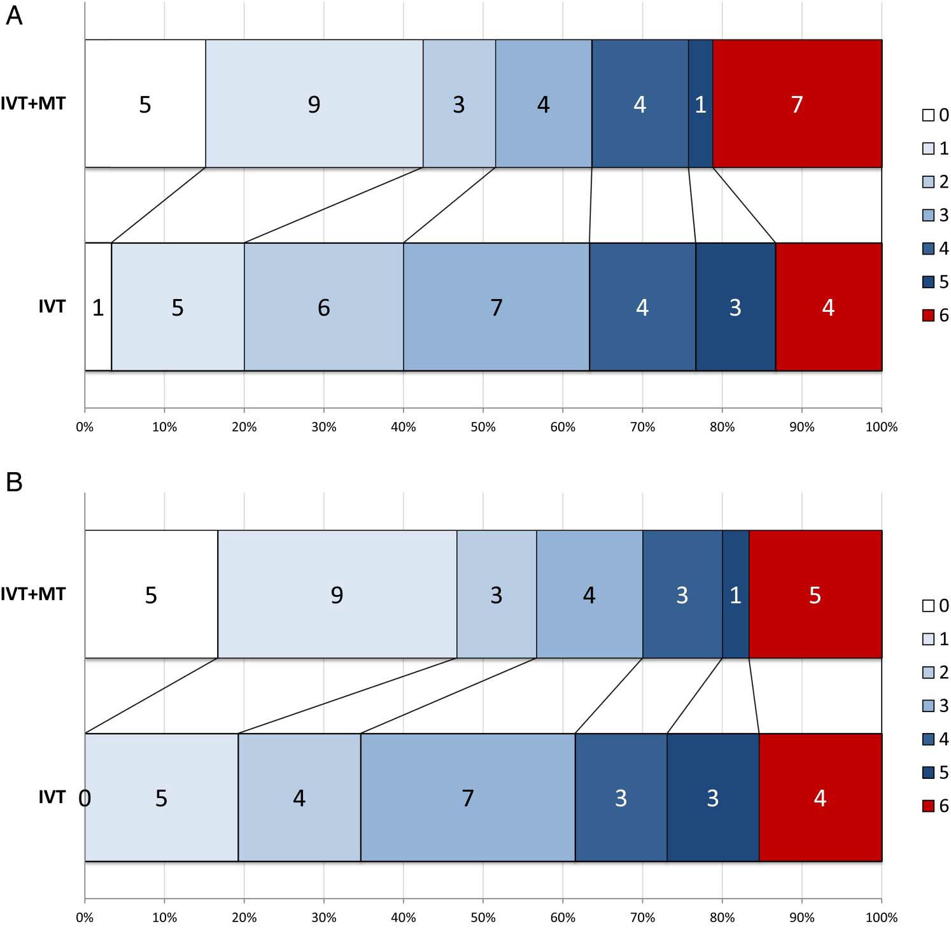
Figure 2 mRS distribution at day 90 in (A) ITT population and
(B) per-protocol population. ITT, intention to treat; IVT, intravenous thrombolysis; mRS, modiﬁed Rankin Scale; MT, mechanical thrombectomy.

 | Intravenous rtPA (IVT) | IVT+MT
n | 32 | 33
No. with any SAE | 11 (34%) | 15 (45%)
No. of SAEs reported | 15 | 21
Probably or definitely related to study procedures | 3 | 2
Fatal SAEs | 4 | 7

although the direction of effects was consistently in favour of the additional MT group (table 2).
Table 3 Serious adverse events
No. fatal SAEs <7 days after onset
Fatal neurological events
<7 days after onset Intracerebral haemorrhage events
Any ICH SICH
ICH events on CT HI1 or HI2 PH1
PH2
Non-ICH SAEs
Anaemia
MI/acute coronary syndrome Gingival bleeding Pneumonia
Brain swelling
Recurrent ischaemic stroke
Neurological deterioration, not definitely ICH or swelling
Other
1
6
1
4
3
0
3
0
12
1
0
12
0
2
1
4
2
0
0
13
1
2
18
1
1
0
5
4
3
1
3 (CCF, UTI,
psychiatric)
3 (pulmonary embolism, osteoarthritis, UTI)
CCF, congestive cardiac failure; HI1/HI2, haemorrhagic infarction types 1 or 2; ICH, intracerebral haemorrhage; IV, intravenous; MI, myocardial infarction; MT, mechanical thrombectomy; PH1/2, parenchymal haematoma types 1 or 2; rtPA, recombinant tissue plasminogen activator; SAE, serious adverse event; SICH, symptomatic intracerebral haemorrhage; UTI, urinary tract infection.

Safety
In the ITT population, there were more deaths in the MT group (7 vs 4), but mortality did not differ signiﬁcantly between IVT alone and IVT+MT groups (table 2). In the IVT group, one death was due to early brain swelling and three due to later complications ( pneumonia or acute myocardial infarction (MI) 22–28 days after randomisation). In the IVT+MT group, four deaths were due to brain swelling and neurological deterioration (two of these in cases where recanalisation was not achieved and one in a patient excluded in the per-protocol analysis), one death from acute MI, one from aspiration pneumonia within the ﬁrst week and one death due to pneumonia occurred later (27 days). There were no SICH events meeting SITS-MOST def- inition. Other ICH and adverse events are detailed in table 3. Three recurrent ischaemic stroke events in the MT group were not considered related to thrombus extraction in any case: two occurred 48–72 hours after the presenting event in patients with atrial ﬁbrillation; the third occurred on the day of MT in a patient also in atrial ﬁbrillation. The two patients with recurrent ischaemic stroke post-MT were on antiplatelet therapy only at the time of the event.

DISCUSSION
The PISTE trial was the only randomised controlled trial of MT in which a policy of proceeding as rapidly as possible to inter- vention on the basis of CTA conﬁrmation of relevant LAO was pursued, in contrast to trials that either by protocol or in prac- tice delayed endovascular treatment to assess the effects of IVT (MR CLEAN and REVASCAT)10 14 or employed additional per- fusion or intracranial collateral vessel imaging to select patients (ESCAPE, EXTEND-IA, SWIFT-Prime11–13). The ﬁndings are consistent with those reported from other clinical trials of MT. While the primary end point was not signiﬁcant in the ITT population, a signiﬁcantly greater proportion of patients allo- cated MT achieved the important secondary end point of excel- lent neurological recovery to mRS ≤1, and all major efﬁcacy
end points signiﬁcantly favoured MT in the per-protocol popu-
lation. The magnitude of estimated treatment effect was similar to those reported in other recent trials of MT (table 4).25
Interventional procedures for acute ischaemic stroke have been undertaken increasingly in healthcare systems that reim- burse these procedures since regulatory approval of endovascu- lar devices from the mid-2000s.26 In contrast, few procedures have been undertaken in the UK, where interventional manage- ment of stroke has been uncommon, except in a small number of centres.
The efﬁcacy of thrombectomy for large artery occlusive ischaemic stroke was ﬁrst shown in a randomised trial in MR CLEAN10 and conﬁrmed by results from four subsequently pub- lished trials (EXTEND-IA,12 ESCAPE,11 SWIFT-prime13 and REVASCAT14). Like PISTE, these four trials, and also two further endovascular trials that have been presented but not yet published (THRACE and THERAPY), were terminated prema- turely after interim review of data by trial data monitoring com- mittees in response to the MR CLEAN results. We continued recruitment to PISTE up until the presentation of THRACE in April 2015 since PISTE addressed a subtly different question compared to the other trials that had been published and MT was not an accepted standard of care in the UK until April 2016. Early discontinuation of the trial led to small sample size, which is likely to be the main factor in the lack of signiﬁcant dif- ference between groups for the primary end point, since process indicators do not suggest any signiﬁcant difference in speed of intervention or effectiveness of the intervention (table 4). Our results are consistent with the beneﬁt shown for MT in larger trials, including a signiﬁcant increase in the proportion of patients achieving excellent recovery. As with previous studies, there were no safety issues, with respect to mortality, intracereb- ral haemorrhagic events or general adverse events.
MR CLEAN and REVASCAT delayed MT initiation in order to evaluate the effectiveness of intravenous rtPA—expli- citly in the REVASCAT protocol, which stipulated a minimum 30 min delay in MT, and implicitly in MR CLEAN. Both trials were characterised by early initiation of IVT but then long delays to randomisation and intervention, and conse- quently later reperfusion than the other three published trials. Effect size estimates were somewhat lower. The three trials that did not delay MT, and recommended proceeding as fast as possible to intervention regardless of IVT, were more selective and all reported larger effect sizes and shorter reper- fusion times, but interpretation is confounded by the use in each of these trials of additional advanced imaging selection using perfusion imaging12 13 or ASPECTS+collateral imaging scoring.11 Of the two unpublished trials, THRACE

 | PISTE |  | MR CLEAN | ESCAPE | EXTEND IA | SWIFT Prime | REVASCAT
n | 65 |  | 500 | 315 | 70 | 196 | 206
Key process times (MT arm), min, median
Onset to IVT |  | 120 | 85 | 110 | 127 | 110 | 117
Onset to randomisation |  | 150 | 204 | 169 | 156 | 191 | 223
Onset to groin puncture |  | 209 | 260 | 208 | 210 | 224 | 269
Onset to reperfusion |  | 259 | 332 | 241 | 248 | 229* | 355
TICI 2b-3 |  | 87% | 59% | 72% | 86% | 88% | 66%
Absolute effect size
mRS 0–1 at day 90 |  | 24% | 6% | 19% | 23% | 22% | 12%
mRS 0–2 at day 90 |  | 14% | 14% | 25% | 31% | 24% | 15.5%
mRS 5–6 |  | 2% | −7% | −14% | −23% | −17% | −6%
Mortality |  | 9% | −1% | −9% | −11% | −4% | 3%

predominantly used MRI for selection, and THERAPY used assessment of clot burden (requiring clot length >8 mm on CT). PISTE was the only trial to use simple imaging (CT and CTA) and a policy of proceeding as fast as possible to MT without additional imaging selection. Onset to reperfusion time was accordingly short, and comparable to the ‘complex imaging’ trials run in experienced MT centres.11–13
Table 4 Comparison of PISTE with published MT trials
*Estimated from interval times reported, but total times not reported.
IVT, intravenous thrombolysis; mRS, modified Rankin Scale; MT, mechanical thrombectomy; TICI, Thrombolysis in Cerebral Infarction.
Previous trials have been based in well-organised regional or national networks (REVASCAT and MR CLEAN), and/or have selected sites that have signiﬁcant experience of MT in addition to highly organised acute IVT services with rigorous centre cre- dentialing.11 13 It was important to establish whether similar effect sizes could be achieved in a healthcare setting where MT was not regarded as ‘standard of care’ and where the supporting networks were less developed. The ﬁndings of PISTE indicate that effect sizes similar to those achieved in the other MT trials are feasible within a less experienced organisational framework and without complex imaging, although the trial relied upon effective multidisciplinary teams within comprehensive stroke centres.
While it is important to regard ﬁndings based on small numbers with caution, the difference between the ITT and per- protocol analyses of PISTE suggests that adherence to strict patient selection criteria may be important in maximising the efﬁcacy of MT. Those excluded from the per-protocol analysis included one crossover to MT in the IVT-only arm, ﬁve patients with inadequate assessment of preprocedure imaging (three more extensive established ischaemic change than permitted; one lack of vascular access to the target vessel due to extensive extracranial arterial occlusion; one ineligible occlusion site) and one patient with signiﬁcant prestroke disability.
Although recent individual patient data and group-level meta-analyses, including the ﬁve published trials, have reﬁned the effect size estimates and allowed some important subgroups to be clariﬁed,25 there remain questions around generalisability, notably whether there are sufﬁcient beneﬁts in some groups of patients (eg, those with extensive early ischaemia, those ineli- gible for IVT), the minimum organisational and training requirements for safe and effective implementation, the role of advanced imaging selection and the cost-effectiveness of MT. Further clinical trials are required to investigate the limits of effectiveness for MT and to provide additional information on absolute effect sizes in different subgroups that will guide service implementation.
While we did not ﬁnd signiﬁcant differences in the primary outcome measure on ITT analysis, the secondary end point of excellent recovery (mRS 0–1) was signiﬁcant in the ITT popula- tion, all mRS-based outcomes were signiﬁcant in favour of MT in the per-protocol population and the effect size estimates were consistent with other trials. We therefore conclude that PISTE conﬁrms the safety of a policy of adjunctive MT based on rela- tively simple imaging (CT+CTA) and supports striking beneﬁt of MT in patients with acute large anterior circulation artery occlusive acute ischaemic stroke and the feasibility of such treat- ment within the UK healthcare system with well-organised ser- vices for delivery of IVT, but only limited prior experience of thrombus extraction for acute stroke.

Author afﬁliations
1Institute of Neuroscience & Psychology, University of Glasgow, Queen Elizabeth University Hospital, Glasgow, UK
2Division of Medical Sciences, Oxford University Hospitals NHS Trust, Oxford
University, Oxford, UK
3Robertson Centre for Biostatistics, University of Glasgow, Glasgow, UK
4St George’s, University of London, London, UK
5Stroke Research Centre, UCL Institute of Neurology, University College London, London, UK
6Department of Neuroradiology, Queen’s Medical Centre, Nottingham, UK 7Institute of Neuroscience, Newcastle University, Newcastle upon Tyne, UK 8Brain Research Imaging Centre, Centre for Clinical Brain Sciences, University of Edinburgh, Edinburgh, UK
9Lay member, Cornwall, UK

Collaborators Trial coordinator: Alicia Murray. Trial Steering Committee (Stroke Association): Gary Ford (chair), Keith Muir, Phil White, Martin M Brown, Andy Clifton, Janet Freeman, Ian Ford; (HTA Phase): Hugh Markus (chair), Joanna Wardlaw. Independent Data Monitoring Committee (Stroke Association): Kennedy Lees, Andy Molyneux, Steff Lewis; (HTA Phase): Tom Robinson, Andy Molyneux, John Norrie. Sites and investigators: University College London Hospital (18)— Fergus Robertson, Richard Perry, Martin M Brown; Newcastle (13)—Anand Dixit, Phil White; St George’s, University of London (12)—Geoff Cloud, Andrew Clifton, Jeremy Madigan; University Hospital of N Staffordshire (6)—Christine Roffe, Sanjeev Nayak; Charing Cross Hospital (5)—Kyriakos Lobotesis; Salford Royal Hospital (5)— Craig Smith, Amit Herwadkar; King’s College Hospital, London (2)—Naga Kandasamy; Leeds (2)—Tony Goddard, John Bamford; Nottingham (1)—Ganesh Subramanian, Rob Lenthall; QE Hospital Birmingham (1)—Edward Littleton, Sal Lamin. Research coordinators: Kelley Storey, Rita Ghatala, Azra Banaras, John
Aeron-Thomas, Bath Hazel, Holly Maguire, Emelda Veraque, Louise Harrison, Rekha Keshvara, James Cunningham.
Contributors KWM is guarantor of the data. Site study coordinators and principal investigators ( physician and interventionalist) are listed and contributed to data acquisition. Additional data analysis was undertaken by JM and RL. The Statistical Analysis Plan was written by C-MM and IF. Statistical analysis was undertaken by

C-MM. The manuscript draft was prepared by KWM and PW with input from all members of the Trial Steering Committee. All authors critically reviewed the manuscript content.
Funding The start-up phase of the trial was funded by grants from the Stroke Association (TSA 2011/2006) from 2012 to 2015 and the National Institute of Health Research (NIHR) Health Technology Assessment programme (HTA 14.08.47) from 2015 to 2016, and received unrestricted grants from Codman and Covidien (Medtronic). MMB’s Chair in Stroke Medicine is supported by the Reta Lila Weston Trust for Medical Research. GAF is supported by an NIHR Senior Investigator Award. Recruitment was predominantly undertaken by NIHR Hyperacute Stroke Research Centres. Part of this work was undertaken at University College London and University College Hospital, which received a proportion of funding from the UK Department of Health’s NIHR Biomedical Research Centres funding scheme. The Systematic Image Review System 2 used for image adjudication was developed and hosted at the University of Edinburgh. Funding for the trial was obtained from the Stroke Association by KWM, PW, IF and JW and from the HTA by KWM, PW, IF, JW, GAF, MMB and AC.
Disclaimer The funding bodies had no role in the design, conduct or interpretation of the trial.
Competing interests The Trial Steering Committee was chaired by GAF (Stroke Association funded phase) and by H Markus (HTA phase). JF was the lay representative on the Trial Steering Committee and participated in all trial design and management decisions. The Data Monitoring Committee was chaired by K R Lees (Stroke Association phase) and by T Robinson (HTA phase); and included S Lewis (Stroke Association phase), J Norrie (HTA phase) and A Molyneux (throughout).
Ethics approval National Research Ethics Service Committee North East-Newcastle and North Tyneside 2 (12-NE-0315). Scotland A Research Ethics Committee (12/SS/ 0059).
Provenance and peer review Not commissioned; externally peer reviewed.
Data sharing statement Reported and additional data have been shared with the HERMES pooling project of stent-retriever trials.
Open Access This is an Open Access article distributed in accordance with the terms of the Creative Commons Attribution (CC BY 4.0) license, which permits others to distribute, remix, adapt and build upon this work, for commercial use, provided the original work is properly cited. See: http://creativecommons.org/licenses/ by/4.0/

REFERENCES
- Rha JH, Saver JL. The impact of recanalization on ischemic stroke outcome: a meta-analysis. Stroke 2007;38:967–73.
- Emberson J, Lees KR, Lyden P, et al. Effect of treatment delay, age, and stroke severity on the effects of intravenous thrombolysis with alteplase for acute ischaemic stroke: a meta-analysis of individual patient data from randomised trials. Lancet 2014;384:1929–35.
- Bhatia R, Hill MD, Shobha N, et al. Low rates of acute recanalization with intravenous recombinant tissue plasminogen activator in ischemic stroke: real-world experience and a call for action. Stroke 2010;41:2254–8.
- Smith WS, Sung G, Saver J, et al. Mechanical thrombectomy for acute ischemic stroke: ﬁnal results of the Multi MERCI trial. Stroke 2008;39:1205–12.
- Penumbra Pivotal Stroke Trial I. The penumbra pivotal stroke trial: safety and effectiveness of a new generation of mechanical devices for clot removal in intracranial large vessel occlusive disease. Stroke 2009;40:2761–8.
- Broderick JP, Palesch YY, Demchuk AM, et al. Endovascular therapy after intravenous t-PA versus t-PA alone for stroke. N Engl J Med 2013;368:893–903.
- Saver JL, Jahan R, Levy EI, et al. Solitaire ﬂow restoration device versus the Merci Retriever in patients with acute ischaemic stroke (SWIFT): a randomised,
parallel-group, non-inferiority trial. Lancet 2012;380:1241–9.
- Nogueira RG, Lutsep HL, Gupta R, et al. Trevo versus Merci retrievers for thrombectomy revascularisation of large vessel occlusions in acute ischaemic stroke (TREVO 2): a randomised trial. Lancet 2012;380:1231–40.
- Khatri P, Yeatts SD, Mazighi M, et al. Time to angiographic reperfusion and clinical outcome after acute ischaemic stroke: an analysis of data from the Interventional Management of Stroke (IMS III) phase 3 trial. Lancet Neurol 2014;13:
567–74.
- Berkhemer OA, Fransen PS, Beumer D, et al. A randomized trial of intraarterial treatment for acute ischemic stroke. N Engl J Med 2015;372:11–20.
- Goyal M, Demchuk AM, Menon BK, et al. Randomized assessment of rapid endovascular treatment of ischemic stroke. N Engl J Med 2015;372: 1019–30.
- Campbell BC, Mitchell PJ, Kleinig TJ, et al. Endovascular therapy for ischemic stroke with perfusion-imaging selection. N Engl J Med 2015;372:1009–18.
- Saver JL, Goyal M, Bonafe A, et al. Stent-retriever thrombectomy after intravenous t-PA vs. t-PA alone in stroke. N Engl J Med 2015;372:2285–95.
- Jovin TG, Chamorro A, Cobo E, et al. Thrombectomy within 8 hours after symptom onset in ischemic stroke. N Engl J Med 2015;372:2296–306.
- Rankin J. Cerebral vascular accidents in patients over the age of 60. 2: prognosis.
Scott Med J 1957;2:200–15.
- van Swieten JC, Koudstaal PJ, Visser MC, et al. Interobserver agreement for the assessment of handicap in stroke patients. Stroke 1988;19:604–7.
- Quinn TJ, Dawson J, Lees JS, et al. Time spent at home poststroke: “home-time” a meaningful and robust outcome measure for stroke trials. Stroke 2008;39: 231–3.
- Wardlaw JM, von Kummer R, Carpenter T, et al. Protocol for the perfusion and angiography imaging sub-study of the Third International Stroke Trial (IST-3) of alteplase treatment within six-hours of acute ischemic stroke. Int J Stroke 2015;10:956–68.
- Wahlgren N, Ahmed N, Davalos A, et al. Thrombolysis with alteplase for acute ischaemic stroke in the Safe Implementation of Thrombolysis in Stroke-Monitoring Study (SITS-MOST): an observational study. Lancet 2007;369:275–82.
- Fiorelli M, Bastianello S, von Kummer R, et al. Hemorrhagic transformation within 36 hours of a cerebral infarct: relationships with early clinical deterioration and
3-month outcome in the European Cooperative Acute Stroke Study I (ECASS I) cohort. Stroke 1999;30:2280–4.
- IST-3 Collaborative Group. Association between brain imaging signs, early and late outcomes, and response to intravenous alteplase after acute ischaemic stroke in the third International Stroke Trial (IST-3): secondary analysis of a randomised controlled trial. Lancet Neurol 2015;14:485–96.
- Barber PA, Demchuk AM, Zhang J, et al. Validity and reliability of a quantitative computed tomography score in predicting outcome of hyperacute stroke before thrombolytic therapy. ASPECTS Study Group. Alberta Stroke Programme Early CT Score. Lancet 2000;355:1670–4.
- Tan IY, Demchuk AM, Hopyan J, et al. CT angiography clot burden score and collateral score: correlation with clinical and radiologic outcomes in acute middle cerebral artery infarct. AJNR Am J Neuroradiol 2009;30:525–31.
- Demchuk AM, Goyal M, Yeatts SD, et al. Recanalization and clinical outcome of occlusion sites at baseline CT angiography in the Interventional Management of Stroke III trial. Radiology 2014;273:202–10.
- Goyal M, Menon BK, van Zwam WH, et al. Endovascular thrombectomy after large-vessel ischaemic stroke: a meta-analysis of individual patient data from ﬁve randomised trials. Lancet 2016;387:1723–31.
- Hassan AE, Chaudhry SA, Grigoryan M, et al. National trends in utilization and outcomes of endovascular treatment of acute ischemic stroke patients in the mechanical thrombectomy era. Stroke 2012;43:3012–17.

