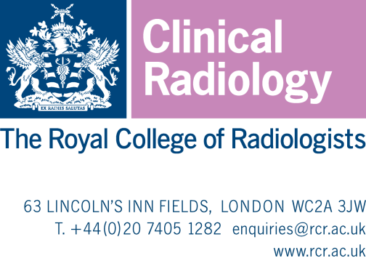

date

Dear

RCR iRefer reviews: call for engagement

The RCR iRefer BSNR panel are seeking Consultant Radiologist volunteers

RCR Editor: Dr Daniel Scoffings

Introduction

iRefer, The Royal College of Radiologists’ (RCR’s) radiological referral guidelines, have been produced for over 20 years and provide practical guidance based on the best available evidence and guides justification under the Ionising Radiation (Medical Exposure) Regulations (IR(ME)R). iRefer is evidence-based and has been developed by drawing on expert contributions from radiology Specialist Interest Group members.

Expert panel members provide the content for the iRefer guidelines via a Delphi consensus process, this contribution is vital to the content remaining current, correct and useful to the referrers into radiology, who rely upon its guidance. RCR awards a minimum of 5 hours CPD points for each guideline undertaken (more if required) and your contribution will be acknowledged on the new website. We will also provide an official appointment letter for your files.
Each guideline is reviewed by a panel of at least 10 consultants, including the Panel Lead. Each section of the guidelines is curated by an RCR Editor, a Radiologist working with us on a consultancy basis with experience in that speciality. The Editor, along with the RCR team carries out as much of the “heavy lifting” of the project as possible to allow the panel to focus on their remit, which is to provide their expert opinion.
Over the next two years we are aiming to review all of the guidelines, and thereafter will move to continuous updating as of guidelines identified as requiring review (although we will have a backstop of a 4 yearly check and literature update). There are 19 guidelines allocated to BSNR left to do, with a further 11 requiign comment alongside other groups, so we need to recruit as many volunteers as possible, with the aim of having as many panels as possible running at once.
Commitment and tenure
If you join a panel, there is no requirement for you to contribute to all of the guidelines presented to that panel, you can dip in and out around your other commitments, it is appreciated if you could kindly let us know in advance for scheduling purposes. Guidelines vary in complexity but with our new process just put in place, it seems that Round 1 can take as little as 30 minutes (including perusing the evidence base in some cases) and Round 2, if needed 10 – 30 minutes.

There is no fixed tenure period, we will continue to include you unless you advise that you would like to step down.
Process
The methodology in brief is that we carry out a literature search of the evidence for each guideline and sift this as much as we can to provide as focused an evidence base as possible. So far, the size of the pool has been between 30 – 80 results with an average of around 50. We provide the abstracts on a word document and lay them out with the conclusion section highlighted to make reading as easy as possible.

New for Autumn 2021. The Editor drafts a proposed updated guideline (or may recommend that no changes outside of minor grammatical points are needed) based on the literature search and their own knowledge and experience. We then carry out a consensus process with using the Survey Monkey platform.

Round one asks for the panel’s recommendations on that draft guideline, and for the top three key pieces of literature to publish alongside the guideline. The draft is presented to the panel alongside a copy of the existing guideline and an interim version with mark-up showing suggested changes. The panel is asked to agree the guideline as written / in principle with tweaks, or to disagree in whole or in part. If we receive 75% agreement from the panel the draft, incorporating the suggested tweaks, proceeds. Feedback suggests this is the longest part of the process including reviewing the literature, with people taking about 3 hours where the evidence pool is large. Completing the survey itself can be as quick as 10 minutes depending on how many comments are made.

On analysis of the Round 1 responses, if 75% agreement is not reached, the Editor drafts an updated guideline based on the recommendations given, which is re-presented at Round 2 in the same way. The new guideline then goes forward for consultation and final approval.

This change to process has been widely well-received by panels using it so far, who have found it much quicker and easier whilst still maintaining quality and allowing them to make their recommendations fully.

Contact

Panellists report that they have found engagement with this project interesting and rewarding, and we do our best to streamline the process to make it run as smoothly as possible. If you would like more information or are considering joining this important project, please get in touch with
Amanda Wells – Irefer Project Manager: Amanda_wells@rcr.ac.uk.

Yours sincerely

Amanda Wells Project Manager

