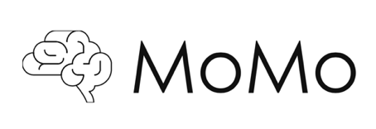

MoMo24
Monday 23rd & Tuesday 24th September 2024
Malmaison, Piccadilly Manchester

Dear Colleague,

Many thanks for your interest in the upcoming national INR Morbidity & Mortality meeting to be held at Malmaison, Manchester.

The format of the meeting will be the same as previous MoMo events with each attendee invited to present a case of severe morbidity or mortality. On arrival each attendee will be asked to sign a non-disclosure agreement creating a closed environment for discussion.

We remind you, as per MHRA guidance, that any significant incident involving a device must be reported to the supplier/manufacturer even if deemed to be operator error.

The meeting has been kindly sponsored by industry suppliers and there is no registration fee.

Accommodation will be provided at Malmaison, Manchester for the night of Monday 20th May 2024. If you require accommodation the night before then this will need to be self-funded.

Spaces are available for consultants who routinely practice neurointervention.

If you would like to attend, please complete the information below and return the form to momointervneuro@gmail.com as soon as possible.

Kind regards,
MoMo Organising Committee
Dr M Cellerini, Dr S Nayak, Dr N Rane, Dr F Robertson & Dr H Stockley

NAME
HOSPITAL
PARENT SPECIALTY | INR / IR / Neurosurgery / Other
DIETARY REQUIREMENTS
ALLERGIES
INTENDED CASE | Aneurysm/Stroke/AVM/Fistula/Spine/Paeds/Other

